

GRADE K

Writing Strategy Steps



TABLE OF CONTENTS

Handout: Writing Phases 3

Handout: Imitate Author’s Craft Anchor Chart 4

Handout: Study the Prompt Anchor Chart 5

Handout: Brainstorm Anchor Chart 6

Handout: Sketch Anchor Chart 7

Handout: Write Orally Anchor Chart 8

Handout: Share Peer Feedback Anchor Chart 9

Handout: Read Your Work Slowly Anchor Chart 10

Handout: Annotate Anchor Chart 11

Handout: Map Anchor Chart 12

Handout: Self-Evaluate Anchor Chart 13

Handout: Sift and Sort Anchor Chart 14

Handout: Collect Evdience Anchor Chart 15

Handout: Use a Checklist Anchor Chart 16

Handout: Read Your Work Aloud Anchor Chart 17

|  |  |
| --- | --- |
| Name: | Date: |

# Handout: Writing Phases

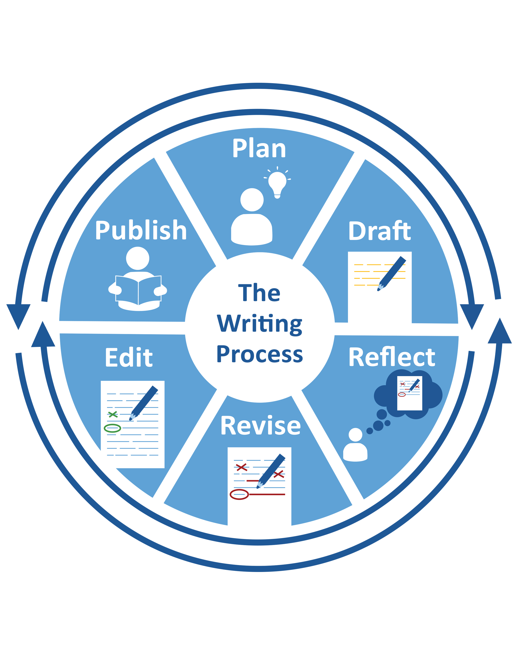

|  |  |
| --- | --- |
| Name: | Date: |

# Handout: Imitate Author’s Craft Anchor Chart

|  |  |
| --- | --- |
| IMITATE AUTHOR’S CRAFT ANCHOR CHART | |
| **Step 1** | Study the example. |
| **Step 2** | Find its parts. |
| **Step 3** | Decide why it is good. |
| **Step 4** | Write your own example. |

|  |  |
| --- | --- |
| Name: | Date: |

# Handout: Study the Prompt Anchor Chart

| STUDY THE PROMPT ANCHOR CHART | |
| --- | --- |
| **Step 1** | Read the prompt. |
| **Step 2** | Find clues for WHO (audience).Name WHO. |
| Find clues for WHAT (format). Name WHAT.  type  length |
| Find clues for WHY (purpose). Name WHY. |
| **Step 3** | Ask questions about WHO, WHAT and WHY. |

|  |  |
| --- | --- |
| Name: | Date: |

# Handout: Brainstorm Anchor Chart

|  |  |
| --- | --- |
| BRAINSTORM ANCHOR CHART | |
| **Step 1** | Decide WHAT to think about.    **?** |
| **Step 2** | Decide HOW:   * Make a list.      * Draw. |
| **Step 3** | Write or draw your ideas. |

|  |  |
| --- | --- |
| Name: | Date: |

# Handout: Sketch Anchor Chart

|  |  |
| --- | --- |
| SKETCH ANCHOR CHART | |
| **Step 1** | Decide WHAT ideas to show. |
| **Step 2** | Make a picture in your mind. |
| **Step 3** | Draw your ideas.    Add labels.    cat |

|  |  |
| --- | --- |
| Name: | Date: |

# Handout: Write Orally Anchor Chart

|  |  |
| --- | --- |
| WRITE ORALLY ANCHOR CHART | |
| **Step 1** | Say your ideas. |
| **Step 2** | Decide if they make sense.  ? |
| **Step 3** | If not, change them.      Ask: Now do they make sense?  ? |
| **Step 4** | Write your ideas. |

|  |  |
| --- | --- |
| Name: | Date: |

# Handout: Share Peer Feedback Anchor Chart

|  |  |
| --- | --- |
| SHARE PEER FEEDBACK ANCHOR CHART | |
| **Step 1** | Tell WHY you are working together. |
| **Step 2** | Decide HOW to work together. |
| **Step 3** | Start your work. |
| **Step 4** | Listen to others’ ideas. |
| **Step 5** | Share your helpful ideas. |

|  |  |
| --- | --- |
| Name: | Date: |

# Handout: Read Your Work Slowly Anchor Chart

|  |  |
| --- | --- |
| READ YOUR WORK SLOWLY ANCHOR CHART | |
| **Step 1** | Name part of your writing to study. |
| **Step 2** | Read it slowly. |
| **Step 3** | Mark what to change.  **A C B D** |
| **Step 4** | Fix the problems.  **A B C D** |

|  |  |
| --- | --- |
| Name: | Date: |

# Handout: Annotate Anchor Chart

|  |  |
| --- | --- |
| ANNOTATE ANCHOR CHART | |
| **Step 1** | Name WHAT to look for. |
| **Step 2** | Decide WHERE to look. |
| **Step 3** | Decide HOW to mark.   * highlight * underline * circle * add a note |
| **Step 4** | Mark as you read. |

|  |  |
| --- | --- |
| Name: | Date: |

# Handout: Map Anchor Chart

|  |  |
| --- | --- |
| MAP ANCHOR CHART | |
| **Step 1** | Decide WHAT to map.   * events **1 2 3**      * topic and details      * opinion and reasons |
| **Step 2** | Make your map. |
| **Step 3** | Write one important idea. |
| **Step 4** | Add more ideas.    **+** |

|  |  |
| --- | --- |
| Name: | Date: |

# Handout: Self-Evaluate Anchor Chart

|  |  |
| --- | --- |
| SELF-EVALUATE ANCHOR CHART | |
| **Step 1** | Think about your writing. Ask:   * Did I meet my writing goals?      * Did I use the best steps for the task?  |  |  | | --- | --- | | **1.** |  | | **2.** |  | | **3.** |  | |
| **Step 2** | Decide on any changes.  **~~A C B D~~  A B C D** |
| **Step 3** | Write new goals. |

|  |  |
| --- | --- |
| Name: | Date: |

# Handout: Sift and Sort Anchor Chart

|  |  |
| --- | --- |
| SIFT AND SORT ANCHOR CHART | |
| **Step 1** | Choose a part to write, like a     * topic sentence.      * character’s name.      * setting description. |
| **Step 2** | Write it different ways. |
| **Step 3** | Try each way in your writing. |
| **Step 4** | Choose one to keep. |

|  |  |
| --- | --- |
| Name: | Date: |

# Handout: Collect Evdience Anchor Chart

|  |  |
| --- | --- |
| COLLECT EVIDENCE ANCHOR CHART | |
| **Step 1** | Name WHAT you are writing.  **?** |
| **Step 2** | Decide what DETAILS you need.   * How many?   **2? 4? 5?**   * What kind? |
| **Step 3** | Name WHERE you can find them. |
| **Step 4** | Decide how to sort them. |
| **Step 5** | Find and sort the details you need. |

|  |  |
| --- | --- |
| Name: | Date: |

# Handout: Use a Checklist Anchor Chart

|  |  |
| --- | --- |
| USE A CHECKLIST ANCHOR CHART | |
| **Step 1** | Read the checklist. |
| **Step 2** | Study your writing.   * Look for checklist examples. |
| **Step 3** | Check the list when you find them. Make changes when you don’t. |

|  |  |
| --- | --- |
| Name: | Date: |

# Handout: Read Your Work Aloud Anchor Chart

|  |  |
| --- | --- |
| READ YOUR WORK ALOUD ANCHOR CHART | |
| **Step 1** | Name part of your writing to study. |
| **Step 2** | Read it aloud. |
| **Step 3** | Mark what to change.  **A C B D** |
| **Step 4** | Fix the problems.  **A B C D** |