GRADE 7
Writing Strategy Steps
TABLE OF CONTENTS
Handout: Writing Phases 3
Handout: Study The Prompt Anchor Chart 4
Handout: Annotate Anchor Chart 5
Handout: Brainstorm Anchor Chart 6
Handout: Map Anchor Chart 7
Handout: Sift and Sort Anchor Chart 8
Handout: Write From the Plan Anchor Chart 9
Handout: Imitate Author’s Craft Anchor Chart 10
Handout: Self-Evaluate Anchor Chart 11
Handout: Read Your Work Slowly Anchor Chart 12
Handout: Publish Anchor Chart 13
Handout: Collect Evidence Anchor Chart 14
Handout: Start Easy Anchor Chart 15
Handout: Share Peer Feedback Anchor Chart 16
Handout: Use A Checklist Anchor Chart 17
Handout: Read Your Work Aloud 18

Name: | Date:

Handout: Writing Phases
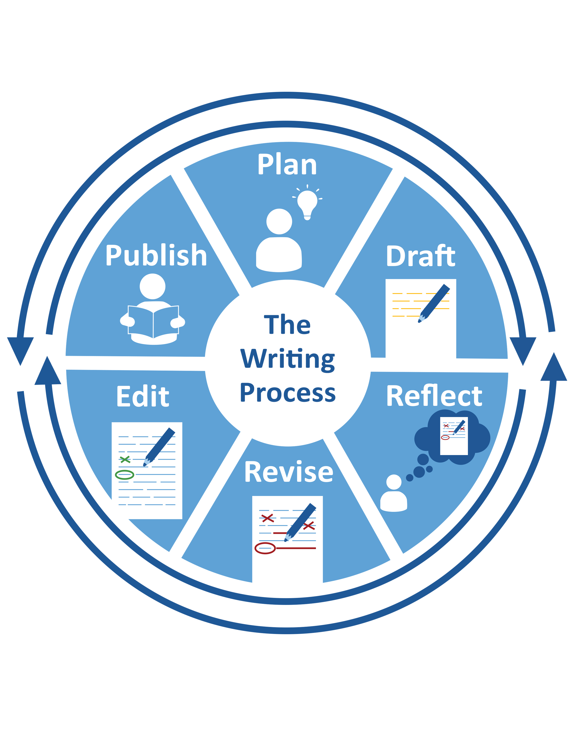

Name: | Date:

Handout: Study The Prompt Anchor Chart

STUDY THE PROMPT ANCHOR CHART
Step 1 | Read the prompt.
Step 2 | - Identify audience (who).  - Identify format (what).  - Identify purpose (why).
Step 3 | Ask questions related to audience, format, and purpose you need to answer.

Name: | Date:

Handout: Annotate Anchor Chart

ANNOTATE ANCHOR CHART
Step 1 | Name what to annotate.
Step 2 | Decide where to look.
Step 3 | Decide how you will mark it.
Step 4 | Read and annotate.

Name: | Date:

Handout: Brainstorm Anchor Chart

BRAINSTORM ANCHOR CHART
Step 1 | Identify what to brainstorm.
Step 2 | Identify questions to answer.
Step 3 | Choose how to answer the questions:  - List ideas.  - Scan in texts.  - Use questions, such as 5W’s + H.  - Use an organizer.
Step 4 | Think and record ideas.

Name: | Date:

Handout: Map Anchor Chart

MAP ANCHOR CHART
Step 1 | Choose a map to fit the task.
Step 2 | Create the map.
Step 3 | Write ideas in your map according to its structure.  - Where does each idea go in the map?  - Do you need more space or to change your map?

Name: | Date:

Handout: Sift and Sort Anchor Chart

SIFT AND SORT ANCHOR CHART
Step 1 | Choose an element to write, like:  - a clear main idea or thesis.  - convincing supporting details.  - vivid images and precise language.  - an effective conclusion.
Step 2 | Write several versions of it.
Step 3 | Try them all in your writing.
Step 4 | Choose one to keep.

Name: | Date:

Handout: Write From the Plan Anchor Chart

WRITE FROM THE PLAN ANCHOR CHART
Step 1 | Review your plan.
Step 2 | Write each idea from your plan as a sentence in order.
Step 3 | Be sure to organize your writing in paragraphs.

Name: | Date:

Handout: Imitate Author’s Craft Anchor Chart

IMITATE AUTHOR’S CRAFT ANCHOR CHART
Step 1 | Read the example.
Step 2 | Annotate the main ideas in the example.
Step 3 | Think about what the author did.  - What is special about the sample?  - What does the author make you feel, see, or understand?  - How exactly did the author accomplish this?
Step 4 | Write like the example.

Name: | Date:

Handout: Self-Evaluate Anchor Chart

SELF-EVALUATE ANCHOR CHART
Step 1 | Study your progress.
Step 2 | Ask: Did I  - meet my writing goals?  - correctly use the best strategies for the task?
Step 3 | Decide on changes to make.
Step 4 | Record new goals to track progress.

Name: | Date:

Handout: Read Your Work Slowly Anchor Chart

READ YOUR WORK SLOWLY ANCHOR CHART
Step 1 | Pick part of your writing to study. Choose one of these elements to study:  - organization  - use of grammar, language, or punctuation  - word choice  - logic and flow of information
Step 2 | Read it slowly.
Step 3 | Annotate what you need to change.
Step 4 | Make any needed changes.

Name: | Date:

Handout: Publish Anchor Chart

PUBLISH ANCHOR CHART
Step 1 | Identify how you will share your work.
Step 2 | Review the rubric.
Step 3 | Finalize your published work by rewriting, typing, or practicing.
Step 4 | Share your work.

Name: | Date:

Handout: Collect Evidence Anchor Chart

COLLECT EVIDENCE ANCHOR CHART
Step 1 | Reread the writing prompt to understand the task.
Step 2 | Decide what evidence you need.  - how much  - what kind
Step 3 | Determine where you can you find the evidence.
Step 4 | Decide the best way to organize the evidence.
Step 5 | Use the organization method to collect evidence.

Name: | Date:

Handout: Start Easy Anchor Chart

START EASY ANCHOR CHART
Step 1 | Review your plan.
Step 2 | Identify an area that is easy to start with.
Step 3 | Write sentences to build that ideas.
Step 4 | Choose another element to write.
Step 5 | Be sure to organize your writing.

Name: | Date:

Handout: Share Peer Feedback Anchor Chart

SHARE PEER FEEDBACK ANCHOR CHART
Step 1 | Think about WHY you are working together.
Step 2 | Identify your goals.
Step 3 | Determine HOW you will work together.
Step 4 | Look or listen to others’ ideas.
Step 5 | Make specific, useful, and respectful suggestions.

Name: | Date:

Handout: Use A Checklist Anchor Chart

USE A CHECKLIST ANCHOR CHART
Step 1 | Study the checklist.
Step 2 | Study your writing. Look for checklist examples.
Step 3 | Check the list when you find them. Make changes when you don’t.

Name: | Date:

Handout: Read Your Work Aloud

READ YOUR WORK ALOUD ANCHOR CHART
Step 1 | Pick part of your writing to study. Choose one of these elements to study:  - organization  - use of grammar, language, or punctuation  - word choice  - logic and flow of information
Step 2 | Read it slowly.
Step 3 | Annotate what you need to change.
Step 4 | Make any needed changes.

