TABLE OF CONTENTS
GRADE 6
Writing Strategy Steps
Handout: Writing Phases 3
Handout: Study the Prompt Anchor Chart 4
Handout: Annotate Anchor Chart 5
Handout: Collect Evidence Anchor Chart 6
Handout: Map Anchor Chart 7
Handout: Write from the Plan Anchor Chart 8
Handout: Sift and Sort Anchor Chart 9
Handout: Imitate Author’s Craft Anchor Chart 10
Handout: Freewrite Anchor Chart 11
Handout: Use a Checklist Anchor Chart 12
Handout: Self-Evaluate Achor Chart 13
Handout: Brainstorm Anchor Chart 14
Handout: Start Easy Anchor Chart 15
Handout: Share Peer Feedback Anchor Chart 16
Handout: Read Your Work Aloud Anchor Chart 17
Handout: Read Your Work from the End to the Beginning Anchor Chart 18

Name: | Date:

Handout: Writing Phases
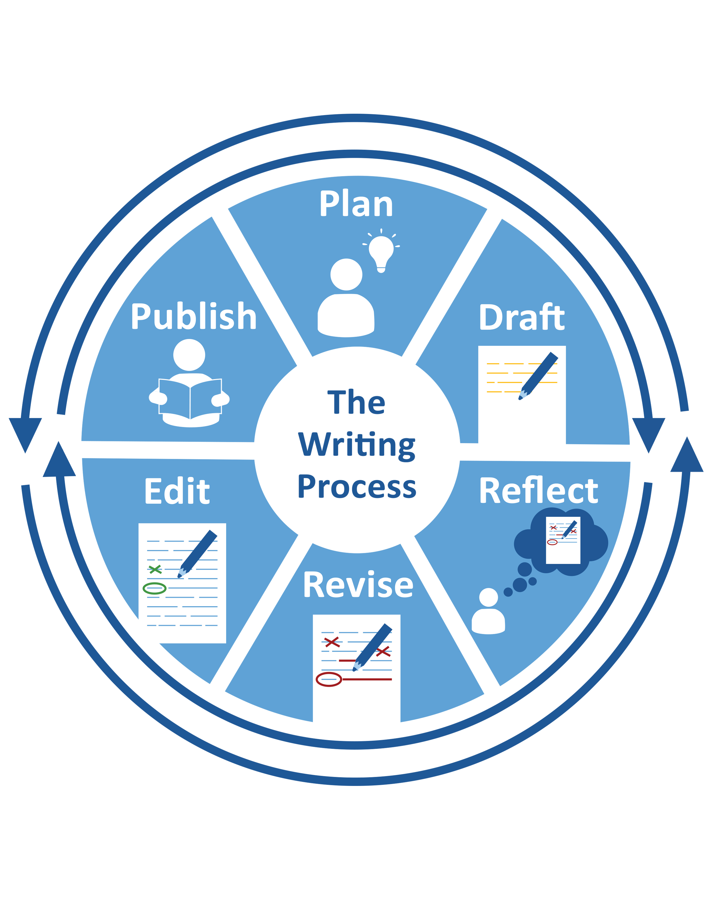

Name: | Date:

Handout: Study the Prompt Anchor Chart

STUDY THE PROMPT ANCHOR CHART
Step 1 | Read the prompt.
Step 2 | Identify the audience (who).
 | Identify the format (what).
 | Identify the purpose (why).
Step 3 | Ask questions related to audience, format, and purpose you need to answer.

Name: | Date:

Handout: Annotate Anchor Chart

ANNOTATE ANCHOR CHART
Step 1 | Name what to annotate.
Step 2 | Decide where you should notice it.
Step 3 | Decide how you will mark it.
Step 4 | Read and annotate.

Name: | Date:

Handout: Collect Evidence Anchor Chart

COLLECT EVIDENCE ANCHOR CHART
Step 1 | Reread the writing prompt to understand the task.
Step 2 | Decide what evidence you need.  - how much  - what kind
Step 3 | Determine where you can find the evidence.
Step 4 | Decide the best way to organize the evidence.
Step 5 | Use the organization method to collect evidence.

Name: | Date:

Handout: Map Anchor Chart

MAP ANCHOR CHART
Step 1 | Choose a map to fit the task.
Step 2 | Create the map.
Step 3 | Write ideas in your map according to its structure.  - Where does each idea go in the map?  - Do you need more space or to change the map?

Name: | Date:

Handout: Write from the Plan Anchor Chart

WRITE FROM THE PLAN ANCHOR CHART
Step 1 | Review your plan.
Step 2 | Write each idea from your plan as a sentence in order.
Step 3 | Be sure to organize your writing in paragraphs.

Name: | Date:

Handout: Sift and Sort Anchor Chart

SIFT AND SORT ANCHOR CHART
Step 1 | Choose an element to write, like:  - a clear main idea or thesis.  - convincing supporting details.  - vivid images and precise language.  - an effective conclusion.
Step 2 | Write several versions of it.
Step 3 | Try them all in your writing.
Step 4 | Choose one to keep.

Name: | Date:

Handout: Imitate Author’s Craft Anchor Chart

IMITATE AUTHOR'S CRAFT ANCHOR CHART
Step 1 | Read the example.
Step 2 | Annotate the main ideas in the example.
Step 3 | Think about what the author did.  What is special about the sample?  What does the author make you feel, see, or understand?  How exactly did the author accomplish this?
Step 4 | Write like the example.

Name: | Date:

Handout: Freewrite Anchor Chart

FREEWRITE ANCHOR CHART
Step 1 | Write without stopping for a set time.
Step 2 | Keep writing even without ideas.  - Write the same word or sentence over and over.  - Write anything you know, think, or wonder about the topic.
Step 3 | Read what you wrote.
Step 4 | Annotate ideas, details, and content to keep.
Step 5 | Zoom in. Build more about one idea:  - Start another freewrite.  - Add to it.  - Respond to it.

Name: | Date:

Handout: Use a Checklist Anchor Chart

USE A CHECKLIST ANCHOR CHART
Step 1 | Study the checklist.
Step 2 | Study your writing. Look for checklist examples.
Step 3 | Check the list when you find them. Make changes when you don't.

Name: | Date:

Handout: Self-Evaluate Achor Chart

SELF-EVALUATE ANCHOR CHART
Step 1 | Study your progress.
Step 2 | Ask: Did I  meet my writing goals?  correctly use the best strategies for the task?
Step 3 | Decide on changes to make.
Step 4 | Record new goals to track progress.

Name: | Date:

Handout: Brainstorm Anchor Chart

BRAINSTORM ANCHOR CHART
Step 1 | Identify what to brainstorm.
Step 2 | Identify questions to answer.
Step 3 | Choose how to answer the questions:  - List ideas.  - Scan in texts.  - Use questions, such as 5W's + H.  - Use an organizer.
Step 4 | Think and record ideas.

Name: | Date:

Handout: Start Easy Anchor Chart

START EASY ANCHOR CHART
Step 1 | Review your plan.
Step 2 | Identify an area that is easy to start with.
Step 3 | Write sentences to build that idea.
Step 4 | Choose another element to write.
Step 5 | Be sure to organize your writing.

Name: | Date:

Handout: Share Peer Feedback Anchor Chart

SHARE PEER FEEDBACK ANCHOR CHART
Step 1 | Think about WHY you are working together.
Step 2 | Identify your goals.
Step 3 | Determine HOW you will work together.
Step 4 | Look at or listen to others' ideas.
Step 5 | Make specific, useful, and respectful suggestions.

Name: | Date:

Handout: Read Your Work Aloud Anchor Chart

READ YOUR WORK ALOUD ANCHOR CHART
Step 1 | Pick part of your writing to study. Choose one of these elements to study:  - organization  - use of grammar, language, or punctuation  - word choice  - logic and flow of information
Step 2 | Read it aloud.
Step 3 | Annotate what you want to change.
Step 4 | Make any needed changes.

Name: | Date:

Handout: Read Your Work from the End to the Beginning
Anchor Chart

READ YOUR WORK FROM THE END TO THE BEGINNING ANCHOR CHART
Step 1 | Pick part of your writing to study. Choose one of these elements to study:  - organization  - use of grammar, language, or punctuation  - word choice  - logic and flow of information
Step 2 | Read from the end to the beginning.  - Start with the last sentence.  - Read each sentence in order from the last to the first.
Step 3 | Annotate what you want to change.
Step 4 | Make any needed changes.

