GRADE 4
Writing Strategy Steps

TABLE OF CONTENTS
Handout: Writing Phases 3
Handout: Study the Prompt Anchor Chart 4
Handout: Brainstorm Anchor Chart 5
Handout: Collect Evidence Anchor Chart 6
Handout: Outline Anchor Chart 7
Handout: Write Orally Anchor Chart 8
Handout: Freewrite Anchor Chart 9
Handout: Sift And Sort Anchor Chart 10
Handout: Self-Evaluate Anchor Chart 11
Handout: Imitate the Author's Craft Anchor Chart 12
Handout: Read Your Work Slowly Anchor Chart 13
Handout: Annotate Anchor Chart 14
Handout: Publish Anchor Chart 15
Handout: Freewrite Anchor Chart 16
Handout: Write From the Plan Anchor Chart 17
Handout: Use a Checklist Anchor Chart 18
Handout: Share Peer Feedback Anchor Chart 19
Handout: Read Your Work Aloud Anchor Chart 20

Name: | Date:

Handout: Writing Phases
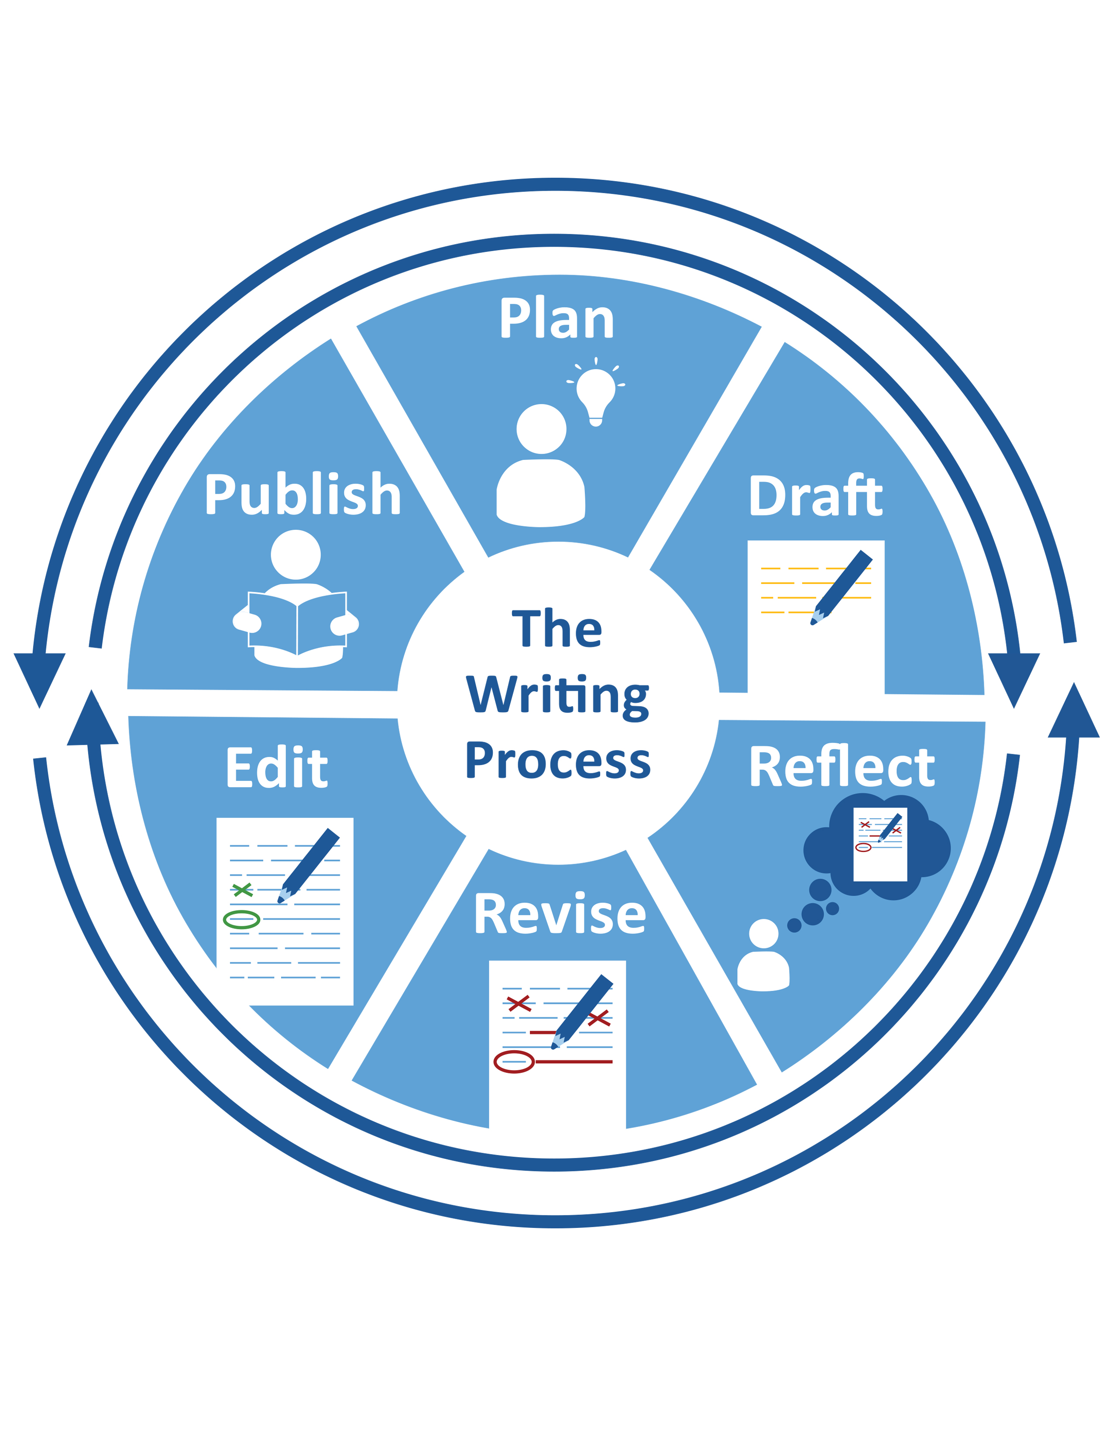

Name: | Date:

Handout: Study the Prompt Anchor Chart

STUDY THE PROMPT ANCHOR CHART
Step 1 | Read the prompt.
Step 2 | - Identify who (audience).  - Identify what (format).  - Identify why (purpose).
Step 3 | Ask questions related to audience, format, and purpose you need to answer.

Name: | Date:

Handout: Brainstorm Anchor Chart

BRAINSTORM ANCHOR CHART
Step 1 | Decide WHAT you will brainstorm.
Step 2 | Decide what questions you will answer.
Step 3 | Determine how you will brainstorm.  - Make a list.  - Scan for ideas.  - Use an organizer.
Step 4 | THINK and record ideas.

Name: | Date:

Handout: Collect Evidence Anchor Chart

COLLECT EVIDENCE ANCHOR CHART
Step 1 | Reread the writing prompt.  - What is the task?
Step 2 | Decide what evidence you need for this task.  - How much?  - What kind?
Step 3 | Determine WHERE to find evidence.
Step 4 | Annotate evidence by circling or flagging words, phrases, or sentences.
Step 4 | Organize the evidence you find.

Name: | Date:

Handout: Outline Anchor Chart

OUTLINE ANCHOR CHART
Step 1 | Identify your topic.
Step 2 | Organize your ideas in groups.
Step 3 | List evidence to support each group of ideas.
Step 4 | Explain your evidence.

Name: | Date:

Handout: Write Orally Anchor Chart

WRITE ORALLY ANCHOR CHART
Step 1 | Say your ideas.
Step 2 | Decide if they make sense.
Step 3 | If not, change them.  - Ask: Now do they make sense?
Step 4 | Write your ideas.

Name: | Date:

Handout: Freewrite Anchor Chart

FREEWRITE ANCHOR CHART
Step 1 | Write for ____ minutes.
Step 2 | Don't stop, even if you get stuck.  - Write words over and over.  - Write anything you know, think, or wonder about the topic.
Step 3 | Read what you wrote.
Step 4 | Annotate ideas and details to keep.
Step 5 | Add more about one idea.

Name: | Date:

Handout: Sift And Sort Anchor Chart

SIFT AND SORT ANCHOR CHART
Step 1 | Choose a part to write, like:  - a topic sentence or main idea.  - supporting ideas or reasons.  - strong details.  - an effective conclusion.
Step 2 | Write it several ways.
Step 3 | Try them all in your writing.
Step 4 | Choose one to keep.

Name: | Date:

Handout: Self-Evaluate Anchor Chart

SELF-EVALUATE ANCHOR CHART
Step 1 | Study your progress.
Step 2 | Ask: Did I:  - meet my writing goals?  - correctly use the best strategies for the task?
Step 3 | Decide on changes to make.
Step 4 | Record new goals to track progress.

Name: | Date:

Handout: Imitate the Author's Craft Anchor Chart

IMITATE THE AUTHOR'S CRAFT ANCHOR CHART
Step 1 | Study the example.
Step 2 | Think about what the author did.  - What is special about the sample?  - What does the author make you feel, see, or understand?  - How does the author accomplish this?
Step 3 | Annotate elements you want to try.
Step 4 | Write like the author’s example.

Name: | Date:

Handout: Read Your Work Slowly Anchor Chart

READ YOUR WORK SLOWLY ANCHOR CHART
Step 1 | Pick part of your writing to study. Choose one of these elements to study:  - organization  - use of grammar, language, or punctuation  - word choice  - logic and flow of information
Step 2 | Read it slowly.
Step 3 | Annotate what you need to change.
Step 3 | Make any needed changes.

Name: | Date:

Handout: Annotate Anchor Chart

ANNOTATE ANCHOR CHART
Step 1 | Name WHAT to annotate.
Step 2 | Decide WHERE to look.
Step 3 | Decide HOW to annotate.  - show: highlight, underline  - draw: arrows, circle  - mark: sticky notes, colors, symbols
Step 4 | Read and annotate.

Name: | Date:

Handout: Publish Anchor Chart

PUBLISH ANCHOR CHART
Step 1 | Identify how you will share your work.
Step 2 | Review the rubric.
Step 3 | Finalize your published work by rewriting or typing.
Step 4 | Share your work.

Name: | Date:

Handout: Freewrite Anchor Chart

FREEWRITE ANCHOR CHART
Step 1 | Write for ____ minutes.
Step 2 | Don't stop, even if you get stuck.  - Write words over and over.  - Write anything you know, think, or wonder about the topic.
Step 3 | Read what you wrote.
Step 4 | Annotate ideas and details to keep.
Step 5 | Add more about one idea.

Name: | Date:

Handout: Write From the Plan Anchor Chart

WRITE FROM THE PLAN ANCHOR CHART
Step 1 | Read your plan.
Step 2 | Write each idea from your plan as a sentence in order.
Step 3 | Be sure to organize the sentences in a logical way.

Name: | Date:

Handout: Use a Checklist Anchor Chart

USE A CHECKLIST ANCHOR CHART
Step 1 | Study the checklist.
Step 2 | Study your writing. Look for checklist examples
Step 3 | Check the list when you find them. Make notes when you don't.

Name: | Date:

Handout: Share Peer Feedback Anchor Chart

SHARE PEER FEEDBACK ANCHOR CHART
Step 1 | Think about WHY you are working together.
Step 2 | Identify your goals.
Step 3 | Determine HOW you will work together.
Step 4 | Look or listen to others’ ideas.
Step 5 | Make specific, useful, and respectful suggestions.

Name: | Date:

Handout: Read Your Work Aloud Anchor Chart

READ YOUR WORK ALOUD ANCHOR CHART
Step 1 | Pick part of your writing to study. Choose one of these elements to study:  - organization  - use of grammar, language, or punctuation  - word choice  - logic and flow of information
Step 2 | Read it aloud.
Step 3 | Annotate what you want to change.
Step 4 | Make any needed changes.

